Security in Computing Practical 3
Configuring Extended ACLs
Practical 3: Configuring Extended ACLs
A]
Topology:
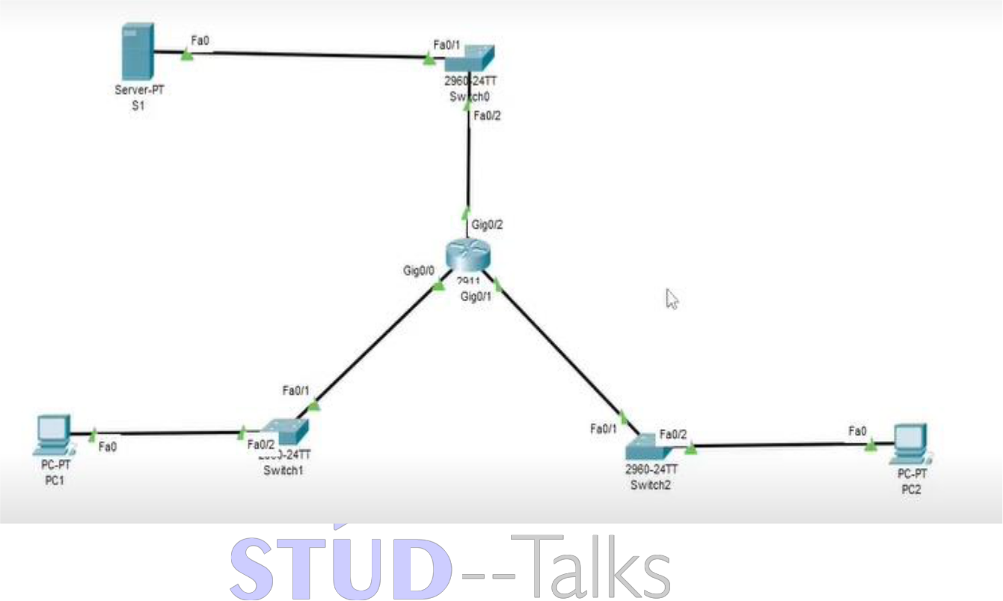

Part A – Router R1 Configuration (Extended ACL)
enable
conf t
hostname R1
enable secret enpa55
line vty 0 4
password vtypa55
login
exit
! Interface configuration
interface g0/0
ip address 172.22.34.65 255.255.255.224
no shutdown
exit
interface g0/1
ip address 172.22.34.97 255.255.255.240
no shutdown
exit
interface g0/2
ip address 172.22.34.1 255.255.255.192
no shutdown
exit
! Extended Numbered ACL (PC1 → FTP only)
access-list 100 permit tcp 172.22.34.64 0.0.0.31 host 172.22.34.62 eq ftp
access-list 100 permit icmp 172.22.34.64 0.0.0.31 host 172.22.34.62
interface g0/0
ip access-group 100 in
exit
! Extended Named ACL (PC2 → HTTP only)
ip access-list extended HTTP_ONLY
permit tcp 172.22.34.96 0.0.0.15 host 172.22.34.62 eq www
permit icmp 172.22.34.96 0.0.0.15 host 172.22.34.62
exit
interface g0/1
ip access-group HTTP_ONLY in
exit
end
wr

Part B – Router RTA Configuration
enable
conf t
hostname RTA
enable secret enpa55
line console 0
password tyit
login
exit
! Interface configuration
interface g0/0
ip address 10.101.117.49 255.255.255.248
no shutdown
exit
interface g0/1
ip address 10.101.117.33 255.255.255.240
no shutdown
exit
interface g0/2
ip address 10.101.117.1 255.255.255.224
no shutdown
exit
! SSH configuration
ip domain-name ccnasecurity.com
username admin secret adminpa55
crypto key generate rsa
1024
line vty 0 4
login local
transport input ssh
exit
! ACL for SSH only + ICMP
access-list 199 permit tcp 10.101.117.32 0.0.0.15 10.101.117.0 0.0.0.31 eq 22
access-list 199 permit icmp any any
interface g0/2
ip access-group 199 out
exit
end
wr

Switch Configuration (SWA, SWB, SWC)
! SWA
conf t
interface vlan 1
ip address 10.101.117.50 255.255.255.248
no shutdown
exit
ip default-gateway 10.101.117.49
! SWB
interface vlan 1
ip address 10.101.117.34 255.255.255.240
no shutdown
exit
ip default-gateway 10.101.117.33
! SWC
interface vlan 1
ip address 10.101.117.2 255.255.255.224
no shutdown
exit
ip default-gateway 10.101.117.1

Verification Steps
1. show ip interface brief
2. show access-lists
3. Test from PC1:
- ping server (should work)
- ftp server (should work)
- ping PC2 (should fail)
4. Test from PC2:
- ping server (should work)
- http server (should work)
- ftp server (should fail)
5. SSH Tests (Part B):
ssh -l admin <IP>
6. Ping allowed but SSH restricted (as per ACL)
Practical 3: Extended ACLs
- On R1:
  - show access-lists: To see the hit count for the numbered ACL (100) and named ACL (HTTP_ONLY).
  - show ip interface g0/0: To verify that access-group 100 is applied "inbound".
- On RTA:
  - show access-lists 199: To verify the SSH and ICMP permit rules.
- Test Connectivity:
  - From PC1: ping the server (success) and ftp the server (success).
  - From PC2: ping the server (success) and attempt http access (success), but ftp should fail.

Practical 3: Extended ACLs
On PC1
- FTP Access: Run ftp 172.22.34.62 (should be successful).
- ICMP Access: Run ping 172.22.34.62 (should be successful).
- Denied Access: Run ping 172.22.34.98 (should show "destination host unreachable").
On PC2
- Web Access: Open Web Browser and go to http://172.22.34.62 (successful).
- FTP Block: Run ftp 172.22.34.62 (should be unsuccessful).

Viva Questions
1. What is ACL?
Access Control List is used to filter network traffic.
2. Difference between Standard and Extended ACL?
Standard → based on source IP
Extended → based on source, destination, protocol, port
3. Why use ACL?
To control and secure network traffic.
4. What is Named ACL?
ACL with a name instead of number.
5. What is port 22?
SSH protocol port.

